**Agentic AI and RAG powered smart study solutions**

**Business Context**

Students today are under constant pressure to keep up with vast amounts of study material like textbooks, class notes, guides, and reference books for every subject. With limited time and growing expectations, going through each document to find specific information becomes stressful and inefficient. They often spend more time searching than actually understanding the content.

A smart solution required which can read and understand all their study materials across subjects. An AI-powered tool can scan this content and make it searchable. So instead of flipping through pages, students can simply ask a question and get quick, accurate answers. This not only saves time but also helps them focus better and learn faster. It's like having a personal tutor that’s always available, making studying less of a struggle and more of a meaningful experience. Such a tool can truly change the way students approach learning in today’s fast-paced world.

**Functional Architecture**

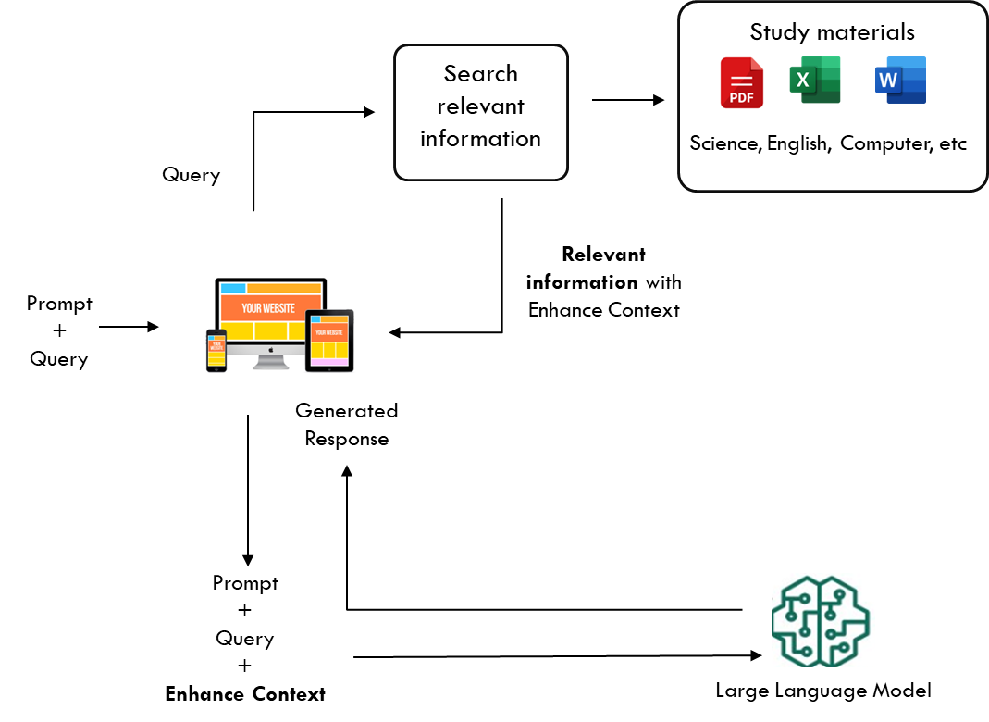

* **Ask a question:** The student types their question in to the application.
* **Look up the right info:** The system checks the uploaded study materials to find the most relevant and recent content.
* **Send it to the AI:** That content is passed along to the AI as background so it understands exactly what the student is asking about.
* **Get a clear answer:** The AI uses that specific material to give a focused, accurate, and easy-to-understand answer based on what the student is actually studying.

**Technical Architecture**

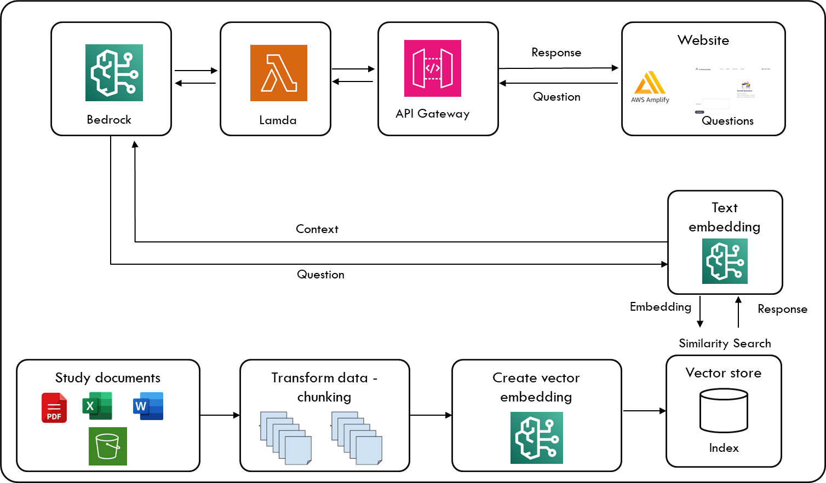

**Benefits**

* **Relevant information** – The answers will come directly from the **student’s own study material, simplified for easy understanding**, not long, generic responses like those from ChatGPT.
* **More time to actually learn** – No need to waste hours flipping through books and notes. Just ask and get what you need instantly.
* **Quick, clear answers when you need them** – Whether it's before a test or while doing homework, get straight-to-the-point help without the usual hassle.
* **Makes tough topics easier to understand** – Instead of struggling alone, get simple explanations that actually make sense.
* **24/7 Personalized Support** – Like having a personal study buddy who's ready to help anytime, day or night.